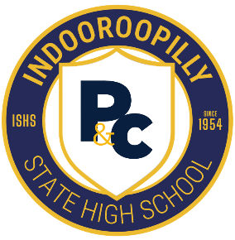
ISHS P&C Community Cookbook
Recipe Submission Template
- Recipe Name:
(Clear, specific name — e.g., “Nonna Rosa’s Lemon Ricotta Cake”)

- Cultural Background or Story (optional but encouraged):
(1–3 sentences about where the recipe comes from, who taught it to you, or why it matters to your family.)

- Ingredients:
(List in the order used. Use metric measurements.)
Example format:
- 2 cups plain flour
- 1 tsp baking powder
- 3 eggs
- 150 g butter, melted
- Method
(Short, clear steps. Numbered. One action per line.)
Example format:
- Preheat oven to 180°C.
- Mix flour and baking powder in a bowl.
- Whisk eggs and sugar until pale.
- Fold wet and dry ingredients together.

- Serving Information
Serves:
(e.g., 4 people, 12 muffins, 1 loaf)
Prep Time:
(e.g., 15 minutes)
Cook Time:
(e.g., 30 minutes)
- Tips, Variations, or Notes (optional)
(e.g., “Add chilli for heat”, “Freezes well”, “Swap chicken for tofu”, “Great for lunchboxes”.)
- Photo Upload (optional but appreciated)
(A quick phone photo in natural light is perfect. Please only submit a photo that has been taken by you.)
- Contributor Details
Your Name:
(Or write “Anonymous” if preferred.)
Connection to the School:
(Student, Parent/Carer, Staff Member, Alumni (if so, insert years you were at ISHS), Friend of the School Community)
- Copyright & Permissions
By submitting this recipe, I confirm that:
- The instructions and any accompanying text are my own original work
- I have not copied text from a cookbook, website, blog, or other publication
- Any photo I upload was taken by me
- I give permission for the P&C to publish this recipe, my name (or anonymous), and any photo provided, in the community cookbook
[ ] I agree (insert “X” to show you agree.)

This cookbook is a labour of love created by volunteers in our school community. We’re grateful for every recipe shared with us. Because we’re working with limited time and a small publication budget, we may not be able to include every recipe in this first edition. Please know that every contribution is valued, and we will do our very best to represent as many families and cultures as we can.

Please email the completed form to Tina at cookbook@ishspandc.org.au by Friday 15 May 2026.

